Trisia Baltazar

Due:11/27/17

A10 part A

CIS 310-02

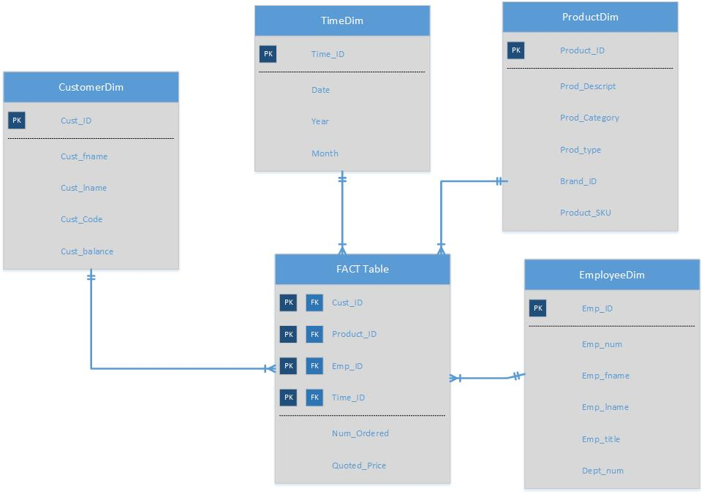

--A10 part B-1

--DIMENSION TABLES

CREATE TABLE PRODUCTDIM

(

PRODUCTID INT IDENTITY NOT NULL,

PROD_SKU VARCHAR(50) NOT NULL,

PROD_DESCRIPT VARCHAR(100) NOT NULL,

PROD_TYPE VARCHAR(50) NOT NULL,

BRAND_ID INT NOT NULL,

BRAND_NAME VARCHAR (50) NOT NULL,

BRAND_TYPE VARCHAR (50) NOT NULL,

)

CREATE TABLE TIMEDIM

(

TIMEID INT IDENTITY NOT NULL,

INV_DATE DATETIME NOT NULL,

YEAR INT NOT NULL,

MONTH INT NOT NULL,

QUARTER INT NOT NULL

)

CREATE TABLE CUSTOMERDIM

(

CUSTOMERID INT IDENTITY NOT NULL,

CUST_CODE INT NOT NULL,

CUST_FNAME VARCHAR(50) NOT NULL,

CUST_LNAME VARCHAR (50) NOT NULL,

CUST_CITY VARCHAR (50) NOT NULL,

CUST_STATE VARCHAR (50) NOT NULL,

CUST_ZIP INT NOT NULL

)

CREATE TABLE EMPLOYEEDIM

(

EMPLOYEEID INT IDENTITY NOT NULL,

EMP_NUM INT NOT NULL,

EMP_FNAME VARCHAR(50) NOT NULL,

EMP_LNAME VARCHAR (50) NOT NULL,

EMP_TITLE VARCHAR (50) NOT NULL,

DEPT_NUM INT NOT NULL,

DEPT_NAME VARCHAR(50) NOT NULL

)

CREATE TABLE FACT

(

PRODUCTID INT NOT NULL,

TIMEID INT NOT NULL,

CUSTOMERID INT NOT NULL,

EMPLOYEEID INT NOT NULL,

LINE_QTY NUMERIC(18,0) NULL,

LINE_PRICE NUMERIC (8,2) NULL

)

CREATE TABLE STAGING

(

PRODUCTID INT ,

TIMEID INT ,

CUSTOMERID INT ,

EMPLOYEEID INT ,

PROD_SKU VARCHAR(50) ,

INV_DATE DATETIME ,

CUST_CODE INT ,

EMP_NUM INT ,

LINE_QTY NUMERIC(18,0) ,

LINE_PRICE NUMERIC (8,2)

)

--TABLE ALTERS

ALTER TABLE PRODUCTDIM

ADD CONSTRAINT PK_PRODUCT PRIMARY KEY (PRODUCTID)

ALTER TABLE TIMEDIM

ADD CONSTRAINT PK_TIME PRIMARY KEY (TIMEID)

ALTER TABLE CUSTOMERDIM

ADD CONSTRAINT PK_CUSTOMER PRIMARY KEY (CUSTOMERID)

ALTER TABLE EMPLOYEEDIM

ADD CONSTRAINT PK_EMPLOYEE PRIMARY KEY (EMPLOYEEID)

ALTER TABLE FACT

ADD CONSTRAINT PK_FACT PRIMARY KEY (PRODUCTID, TIMEID, CUSTOMERID, EMPLOYEEID),

CONSTRAINT FK_FACT_PRODUCT FOREIGN KEY (PRODUCTID) REFERENCES PRODUCTDIM,

CONSTRAINT FK_FACT_TIME FOREIGN KEY (TIMEID) REFERENCES TIMEDIM,

CONSTRAINT FK_FACT_CUSTOMER FOREIGN KEY (CUSTOMERID) REFERENCES CUSTOMERDIM,

CONSTRAINT FK_FACT_EMPLOYEE FOREIGN KEY (EMPLOYEEID) REFERENCES EMPLOYEEDIM